Mars Global Mosaic: Mapping Lava Flows, Fluvial Channels, and Impact Craters in Visible and Infrared
REMOTE SENSING 2026 OCN 4704 · Logan Edwards
Interim Report · status as of 26 October 2026
1. Project Investigators
Logan Edwards, REMOTE SENSING 2026 OCN 4704.
2. Project Goals
Assemble one co-registered visible and thermal-infrared mosaic of Mars in ArcGIS Pro, over the ±60° band the THEMIS night mosaic covers (86.6% of the surface), and use it to map lava flows, fluvial channels and impact craters.
- One co-registered stack: Viking visible colour, THEMIS day and night infrared, HRSC/MOLA topography, on a single grid over ±60°.
- Map and classify the three landform families from it, in a type area first (Ius Chasma) and then across ±60°.
- Test whether thermal infrared separates surfaces that visible light cannot.
- Score every product against something it never saw: held-out hand labels, the IAU crater gazetteer, and the USGS geologic map.
3. Relevant Spectral Bands
Band or product | Wavelength | Cell | What it contributes
Viking MDIM 2.1 R, G, B | visible, ~0.4–0.7 µm | 232 m | Albedo: bright dust against dark basalt. Keeps real regional differences (§28.10).
THEMIS Day IR (v12) | thermal IR, 6.8–14.9 µm | 100 m | Daytime temperature: bright in visible = cool by day (r −0.49 at Ius, §18.3).
THEMIS Night IR (v14, ±60°) | thermal IR, 6.8–14.9 µm | 100 m | Night temperature: rock holds heat. The most independent band, |r| ≤ 0.12 (§18.3).
HRSC/MOLA blended DEM | altimetry + stereo | 200 m | Slope in degrees, local relief, hillshade, flow routing, closed-depression depth (§20).
Diurnal contrast index | day − night, relative | 100 m | A local material discriminator inside one area; not thermal inertia, not planet-wide (§24, §28.10).

Correlation between the five image bands over the Ius Chasma type area (PROJECT-KNOWLEDGE.md §18.3):
r | Viking R | Viking G | Viking B | Day IR | Night IR
Viking R | 1 | +0.960 | +0.925 | −0.486 | −0.121
Viking G | +0.960 | 1 | +0.993 | −0.496 | −0.085
Viking B | +0.925 | +0.993 | 1 | −0.488 | −0.068
Day IR | −0.486 | −0.496 | −0.488 | 1 | +0.105
Night IR | −0.121 | −0.085 | −0.068 | +0.105 | 1

Three visible bands are one dimension (r 0.93–0.99); day IR adds a second, night IR a third. Effective dimensionality ≈ 3: the measured case for fusing them.
4. Project Tasks and Percent Complete
# | Task | Where it stands | 13 Sep | Now
1 | Scope, targets and type area | Ius Chasma and Athabasca Valles type areas; ±60° extent decided | 90% | 100%
2 | Raster acquisition | Three globals + THEMIS Night IR | 100% | 100%
3 | Statistics, stretches, pyramids | Done: all products overviewed, the four source globals in 26 min | 70% | 100%
4 | Grouped mosaic viewer | Done | 100% | 100%
5 | DEM terrain derivatives | Rebuilt in degrees, type area and ±60°; WARNING 000869 gone | 80% | 100%
6 | Image-gradient products | Renamed Gradient_*; not used further | 70% | 100%
7 | Jezero context | Hosted services only; the dead HiRISE link removed | 20% | 100%
8 | Classification | ±60° SVM on hand-drawn labels, 200 m: 73.8%, κ 0.58 held out; seven classes proposed | 20% | 75%
9 | CRS harmonisation | Done: one 100 m / 200 m grid over ±60° | 15% | 100%
10 | Visible + IR composite | Done: type area; 7-band ±60° stack | 5% | 100%
11 | Landform digitising | Classes ready and empty; candidates reviewable; validation sheet ready; 512 training polygons drawn | 0% | 10%
12 | Crater inventory | Robbins catalogue in the project (385,049); 465,354 closed depressions ≥ 1 km at ±60° | 0% | 60%
13 | Map layouts | 17 layouts, from none, with graticules | 0% | 85%
14 | Report and presentations | Prospectus and Presentation 1 delivered; interim built to the 26 Oct cut; final paper and deck drafted | 25% | 60%

5. Processing Completed Since the Last Report
When | What | Outcome | KB
18 Sep | Night IR acquired; type-area stack; slope on a metric grid | Four inputs on one 100 m grid, 100% co-valid; slope in degrees | §15–20
19 Sep | ±60° grids and diurnal contrast index | 15.2 bn px in 36.3 min | §28
19 Sep | Channel and crater candidates, Ius; basins at ±60° | 2,610 channels; 1,685 closed depressions; 5,144 basins ≥ 20 km | §25–28
24–30 Sep | Global composites in the Pro GUI (desktop) | First successes: 2 h 52 m, 3 h 10 m | §29
29 Sep | Hand-drawn training polygons; SVMs | Four classes; two ±60° maps | §29
2–3 Oct | First SVM maps checked; corrected stack scored held out | Tile artefact, mostly elevation; then 73.5%, κ 0.58 | §30–32
6–7 Oct | Backup to GitHub; class codes | Public repository; pixel = class code | §35–36
8 Oct | Reference data, Athabasca, tests T1–T3 and T8 | Thermal adds +1.3 points; ten layouts | §38–44
8–9 Oct | Digitising by review; tests T4–T7; validation sheet | No support for H1–H3 or a tributary count; 12 layouts | §46–51
13–15 Oct | Desktop: pyramids; ±60° craters and channels ≥ 1 km; 180° DEM fix | 465,354 closed depressions, 969,822 channel segments | §53–54
14–16 Oct | 200 m classification; T1 with Pro's SVM; the published map | 73.8%, κ 0.58; thermal adds +1.36 and +1.97 points | §55–57
19–21 Oct | Deep learning: a box detector, then a U-Net over ±60° | U-Net 98.9%, κ 0.98 held out: terrain provinces | §66
22–23 Oct | The 512 labels audited; seven classes proposed (D17) | Five Crater labels are volcanoes; 1,086 proposals to review | §68–69

6. Preliminary Results
Every map is a layout in the ArcGIS project, exported for this report; every number is quoted from the project knowledge base, whose section is given under each figure.
Figure 1. Where: the analysis extent and the two type areas
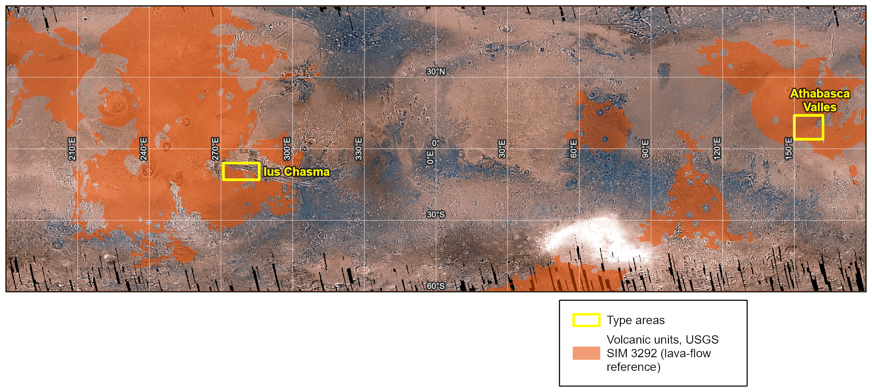
- ±60° latitude, 86.6% of the planet: the THEMIS night mosaic's coverage
- Ius Chasma, canyon and tributaries; Athabasca Valles, flood lava
- Orange: volcanic units of the USGS geologic map, the lava-flow reference
Source: PROJECT-KNOWLEDGE.md §16, §41, §42, §43
Figure 2. The mosaic at ±60°
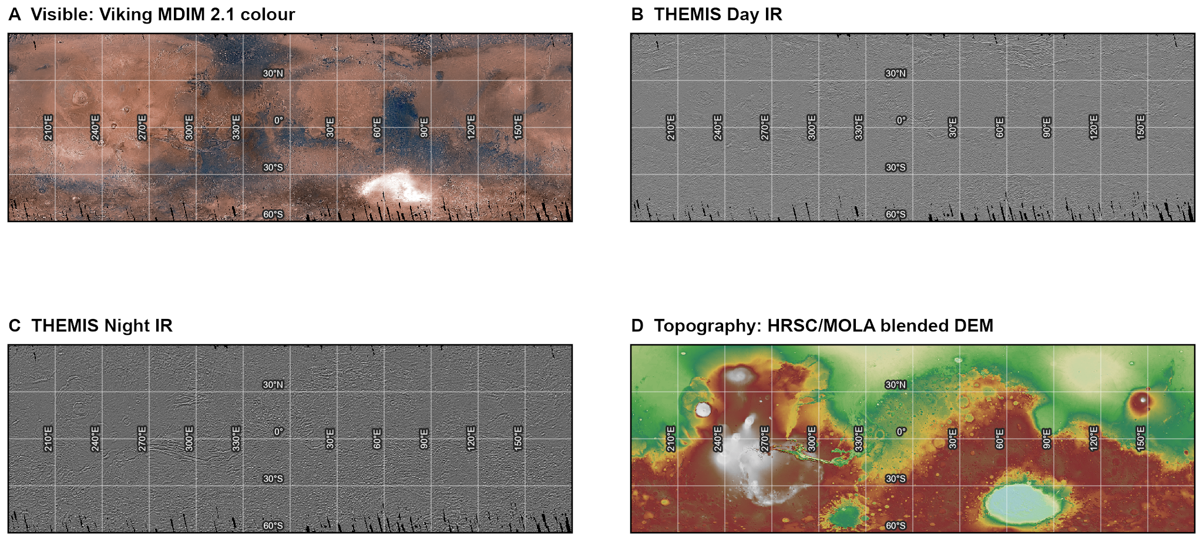
- Four datasets on one 200 m grid for the first time
- The failed global Composite Bands is solved: project first, then bound the extent
- Night-IR coverage sets the extent: 86.6% of the planet
Source: PROJECT-KNOWLEDGE.md §16, §18, §28.1, §38
Figure 3. Ius Chasma type area: visible and night IR
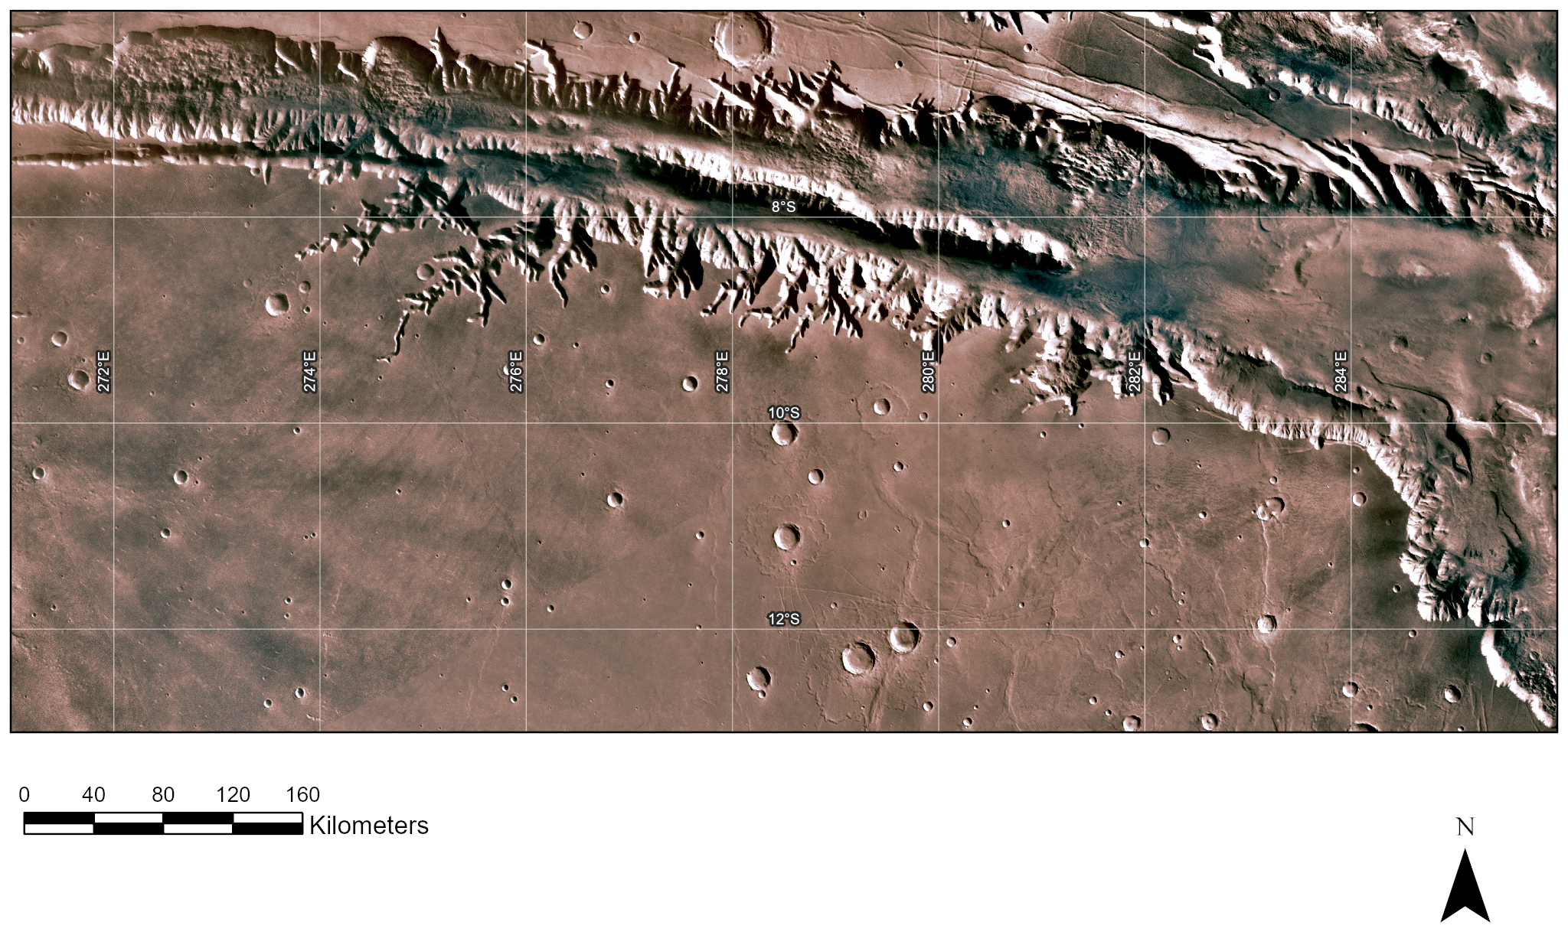 | 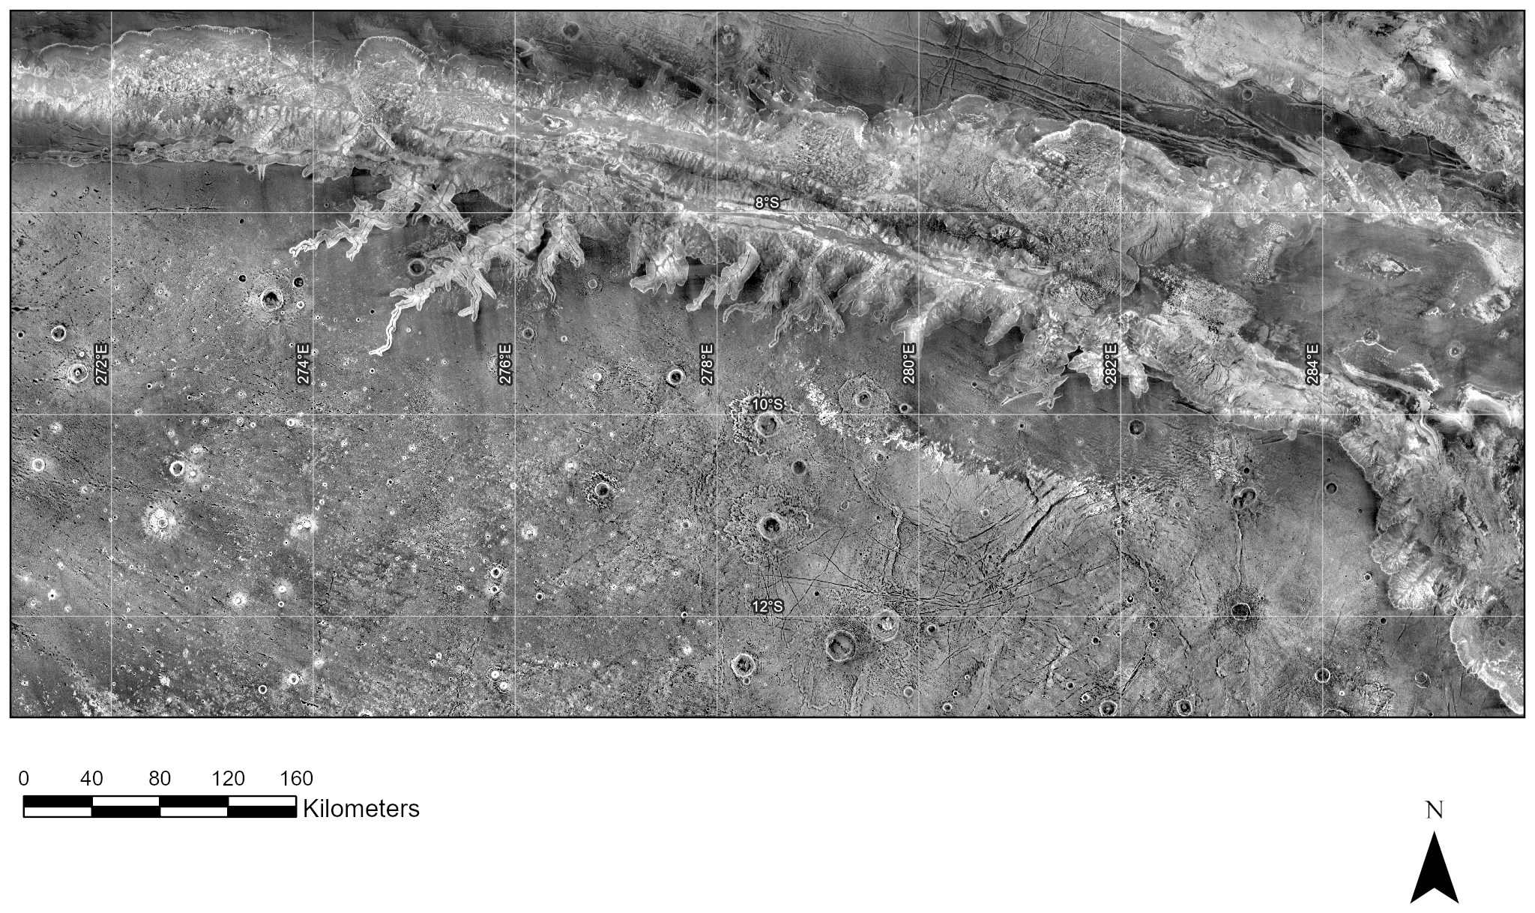
- 271–286°E, 6–13°S: canyon walls, plateau, Louros Valles
- Same 100 m grid, every pixel valid in all five bands
- Night IR correlates |r| ≤ 0.12 with every other band: information no other layer holds
Source: PROJECT-KNOWLEDGE.md §14.3, §18
Figure 4. Can the thermal pair map material across ±60°?
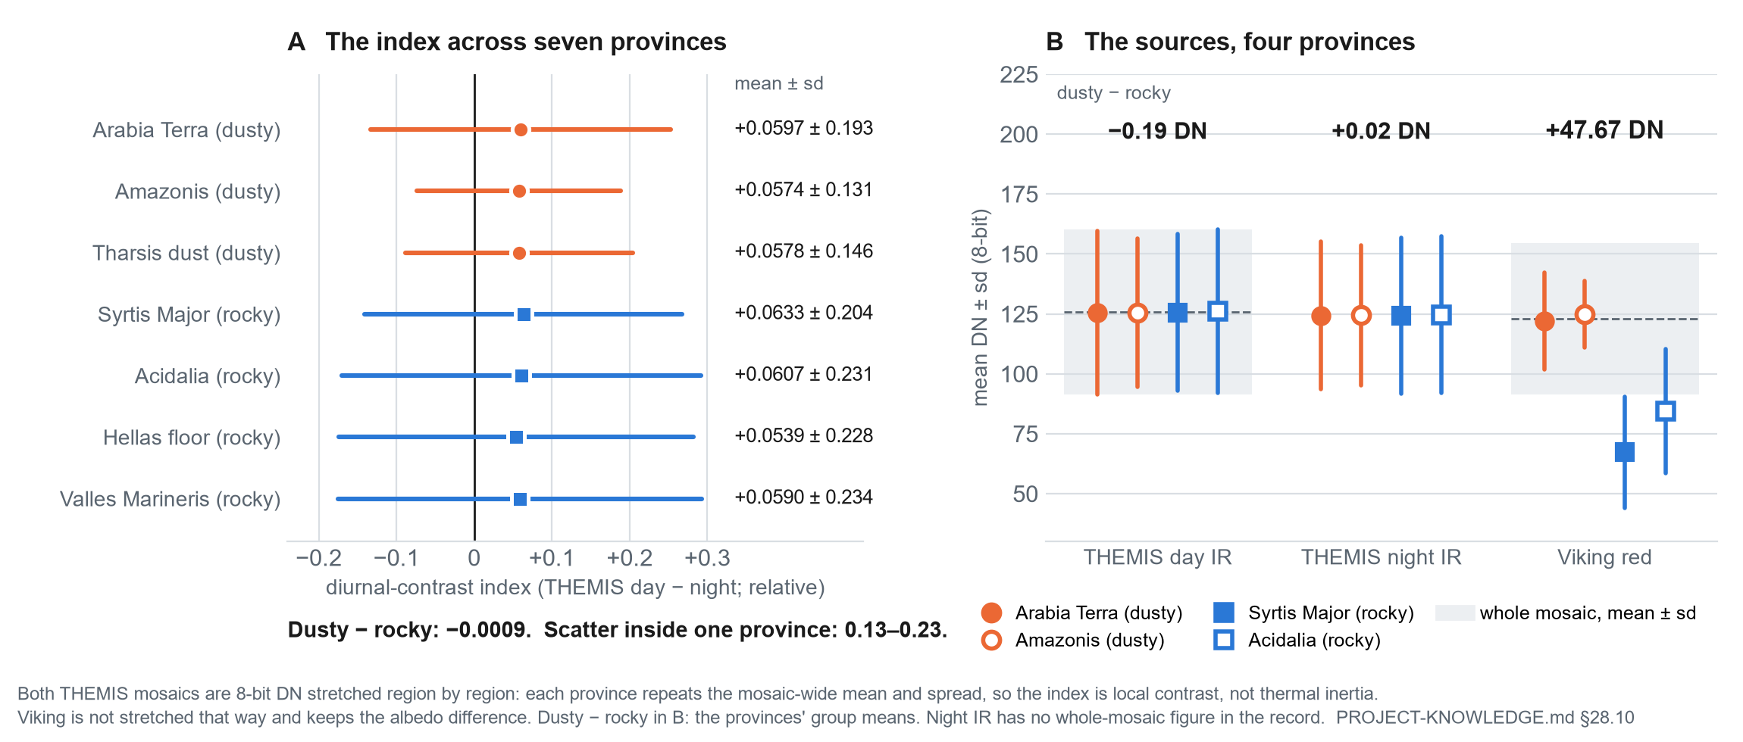
- Viking red separates the dusty provinces from the rocky ones by 47.67 DN
- THEMIS day and night IR: −0.19 and +0.02 DN; the index over seven provinces: −0.0009
- Each province repeats the mosaic-wide mean and spread: contrast-stretched region by region
- Planet-wide, visible albedo carries the material signal
Source: PROJECT-KNOWLEDGE.md §28.10
Figure 5. Checked against calibrated thermal inertia (TES)
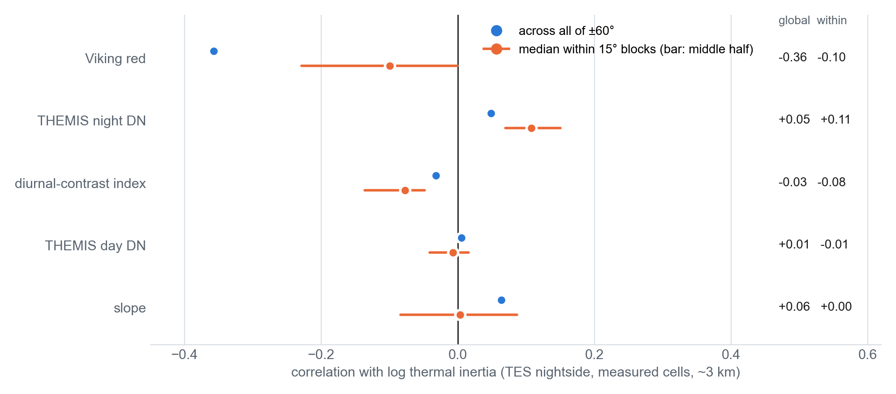
- Viking albedo tracks real thermal inertia across the planet (r −0.36)
- Night IR and the diurnal-contrast index: a weak signal inside regions only (|r| ≈ 0.1)
- Day IR carries none; across the planet the THEMIS pair says nothing
- So the material signal is in visible albedo; thermal IR adds little at 3 km
Source: PROJECT-KNOWLEDGE.md §41, §42.4, §43.1
Figure 6. Craters at ±60°: closed depressions ≥ 20 km
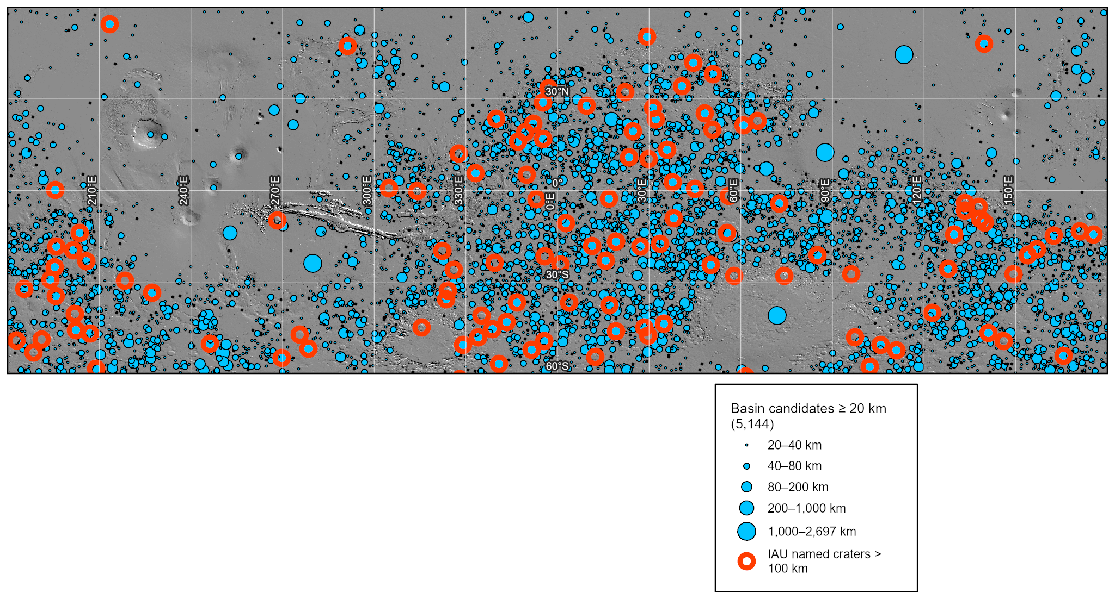
- 5,144 basins found by fill depth in 48 s
- 68% of 117 IAU craters ≥ 100 km recovered, diameter within ±50%
- Diameter error median +2.2%
- Misses breached craters by construction: they are not closed
Source: PROJECT-KNOWLEDGE.md §28.11
Figure 7. Closed depressions ≥ 1 km across ±60°
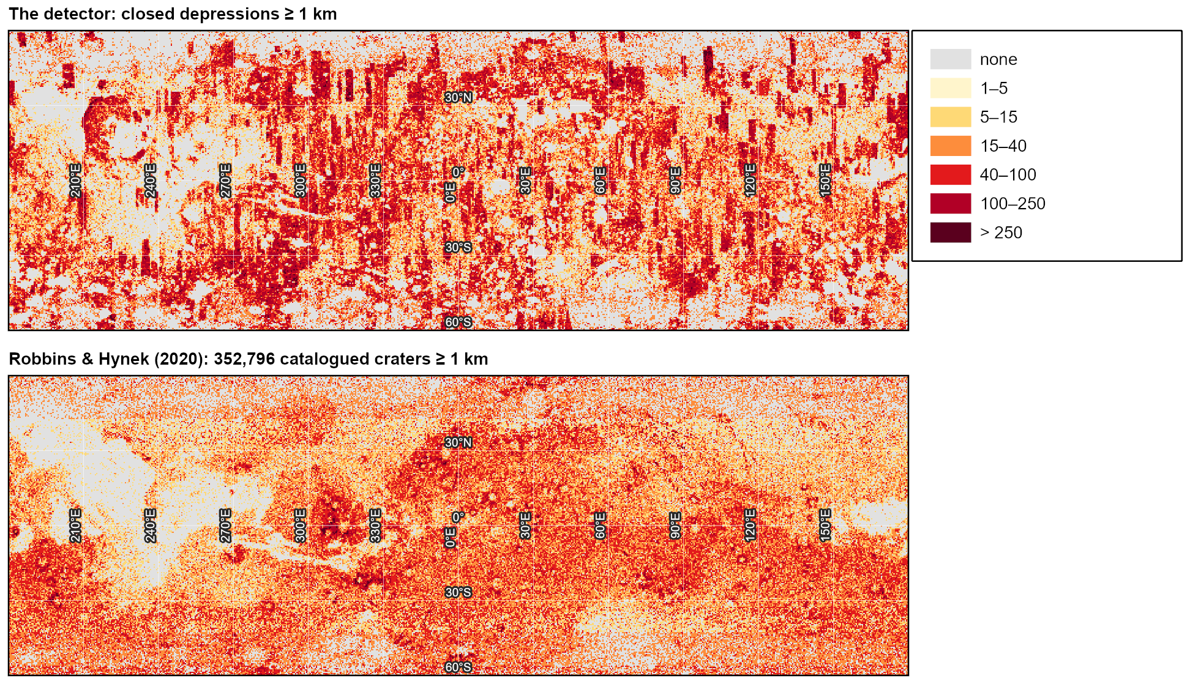
- 465,354 closed depressions ≥ 1 km, from an 11-hour run on the desktop
- Against Robbins: 15.3% are catalogued craters at ≥ 1 km, 62.2% at ≥ 5 km, 83.1% at ≥ 20 km
- Below ~5 km their density follows the DEM's sharpness, not the craters (r −0.11)
- A map of large craters and a list of prompts, not a crater inventory
Source: PROJECT-KNOWLEDGE.md §53.4, §53.6, §54.4, §55.4
Figure 8. Channels across ±60°
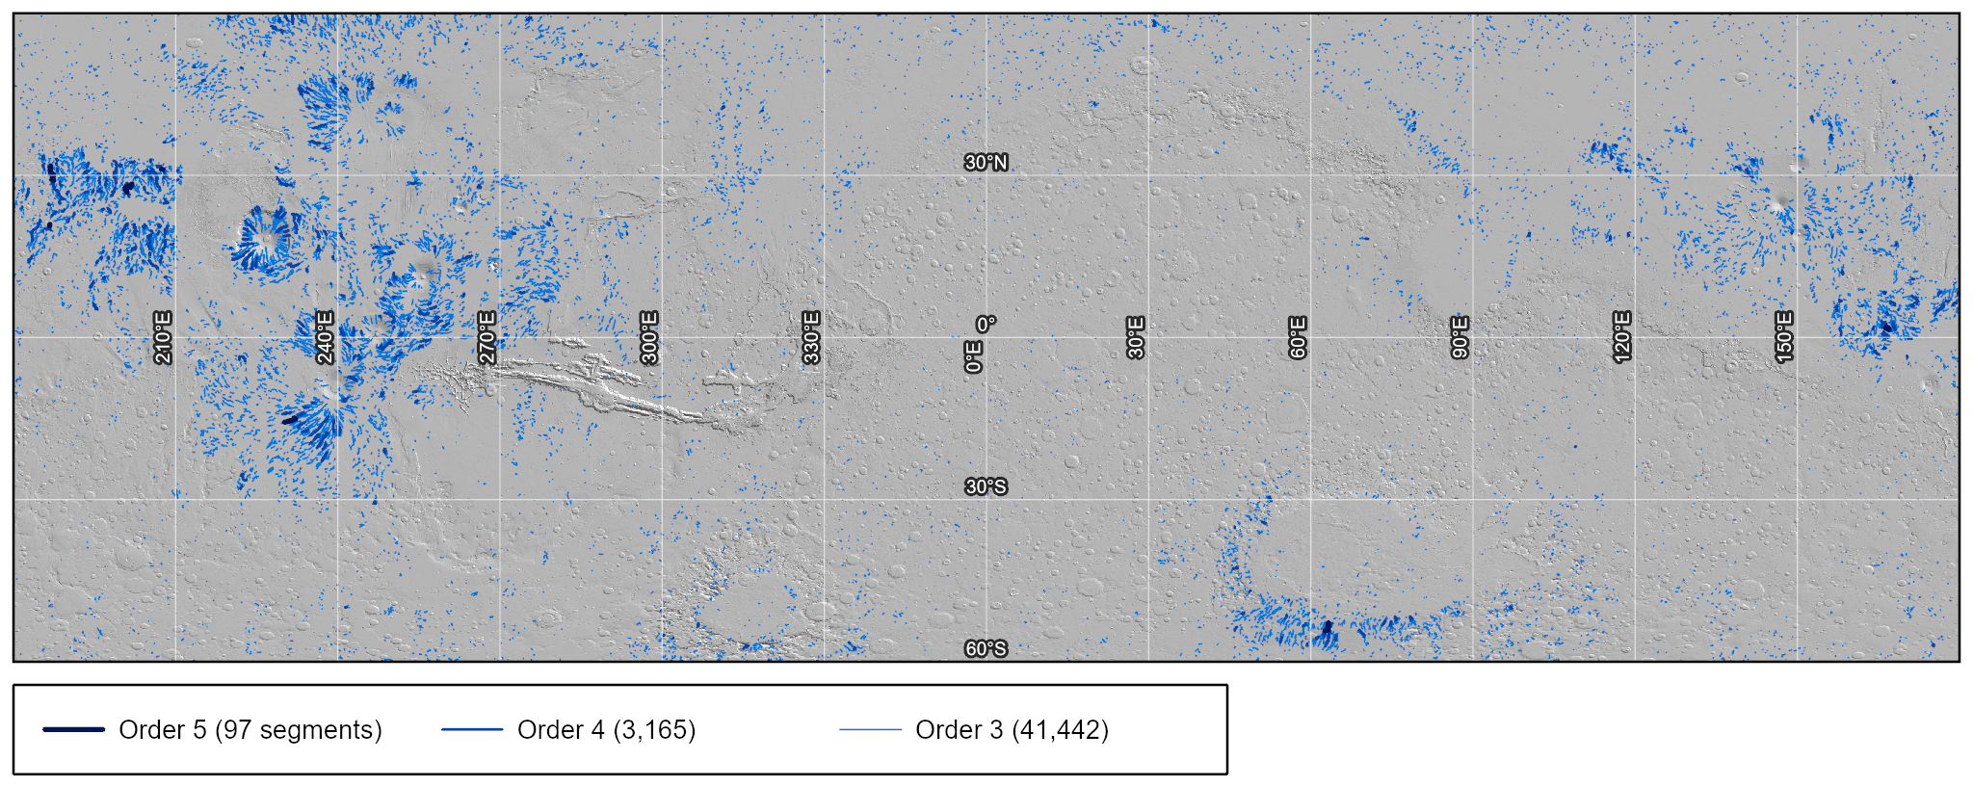
- 969,822 routed channel segments; orders 3–5 drawn
- 60.5% of stream cells discarded as fill artefact (Ius alone: 56%)
- 89.8% lie on ground under 2°: plateau channels are DEM noise
- No channel reference exists at ±60°, so the network is not scored
Source: PROJECT-KNOWLEDGE.md §53.4, §53.6, §54.4, §55.4
Figure 9. Ius Chasma: candidates to digitise
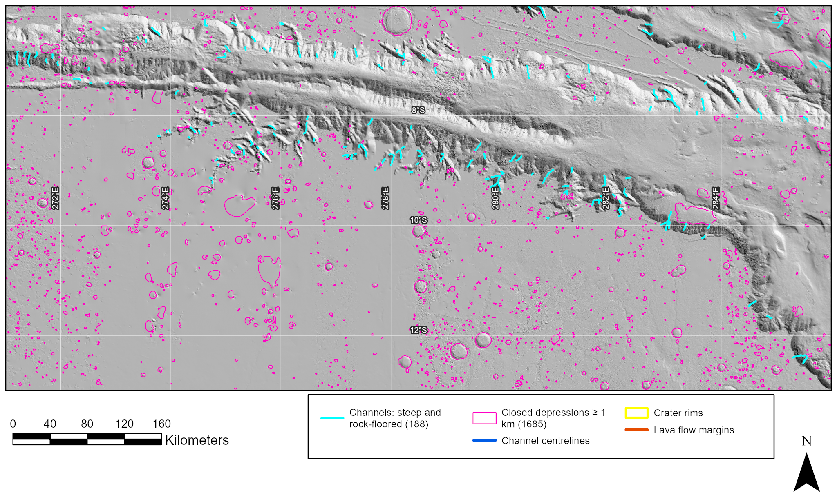
- Fill raised the canyon floor 2,077 m; 56% of the first channel network was artefact
- 188 channel candidates are steep and rock-floored: the place to start
- 1,685 closed depressions ≥ 1 km: only 11% match a catalogued (Robbins) crater, so they are prompts, not a crater count
Source: PROJECT-KNOWLEDGE.md §25, §26, §42.3
Figure 10. Athabasca Valles: the second type area
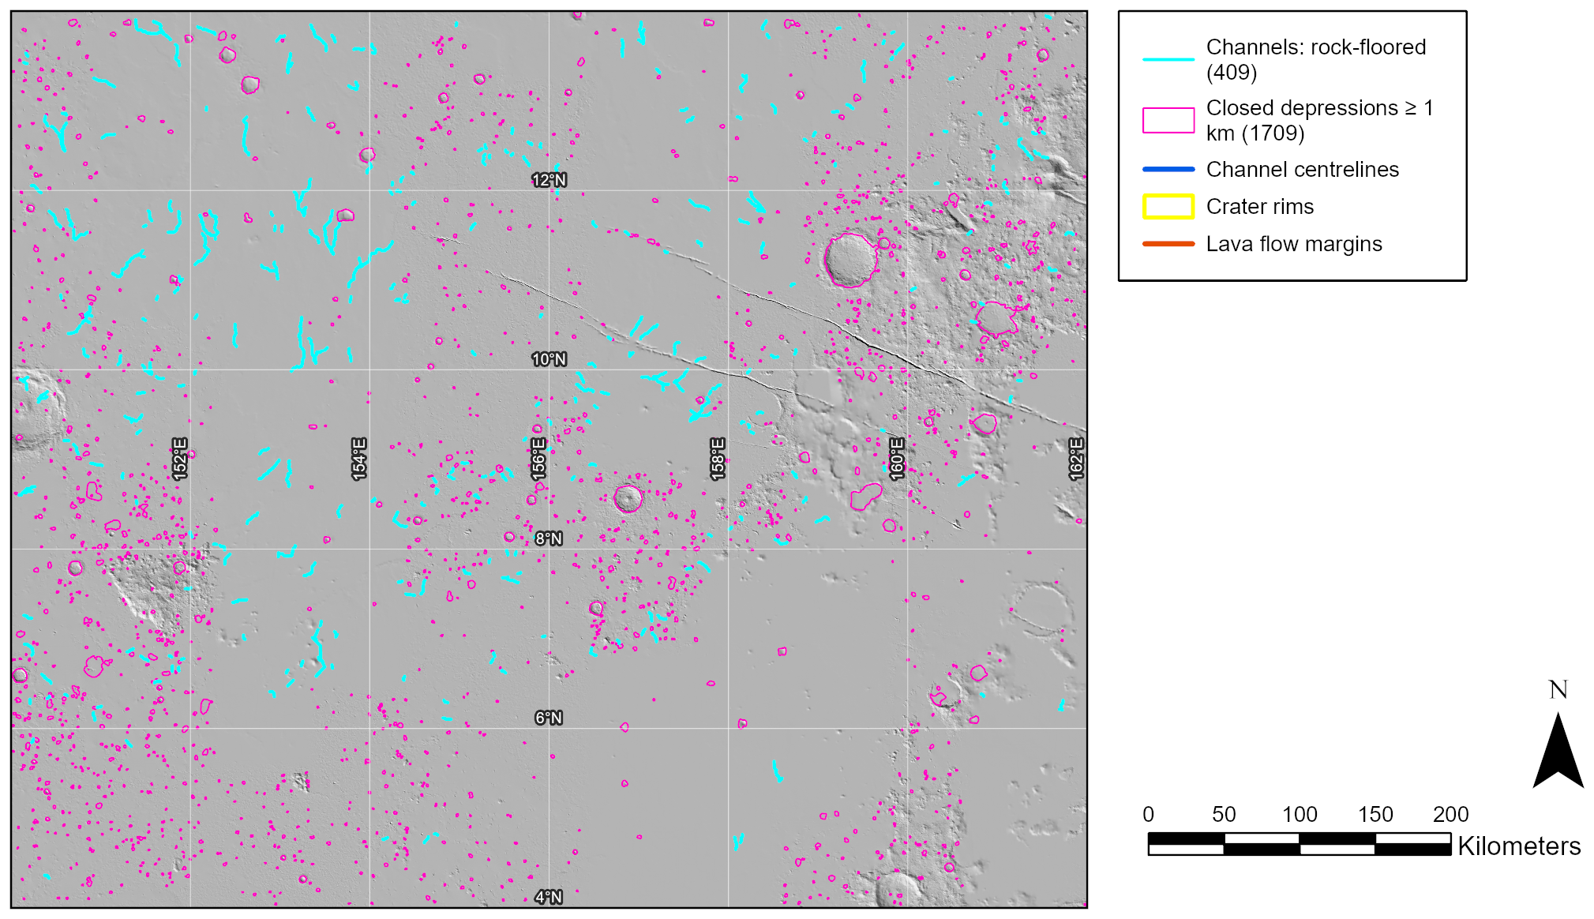
- Flood lava once mapped as a water channel; the USGS map calls it Late Amazonian volcanic (lAv)
- Same 100 m stack, terrain and candidates as Ius: 3,283 channels, 409 rock-floored
- Catalogued craters: 1,122 per million km² on lAv, against 1,760 and 2,183 on the older units
- Calibrated TES inertia: the diurnal-contrast index does not track it (r ≈ 0); Viking albedo does (−0.55)
Source: PROJECT-KNOWLEDGE.md §41, §42
Figure 11. Landforms at ±60°, scored on labels the model never saw
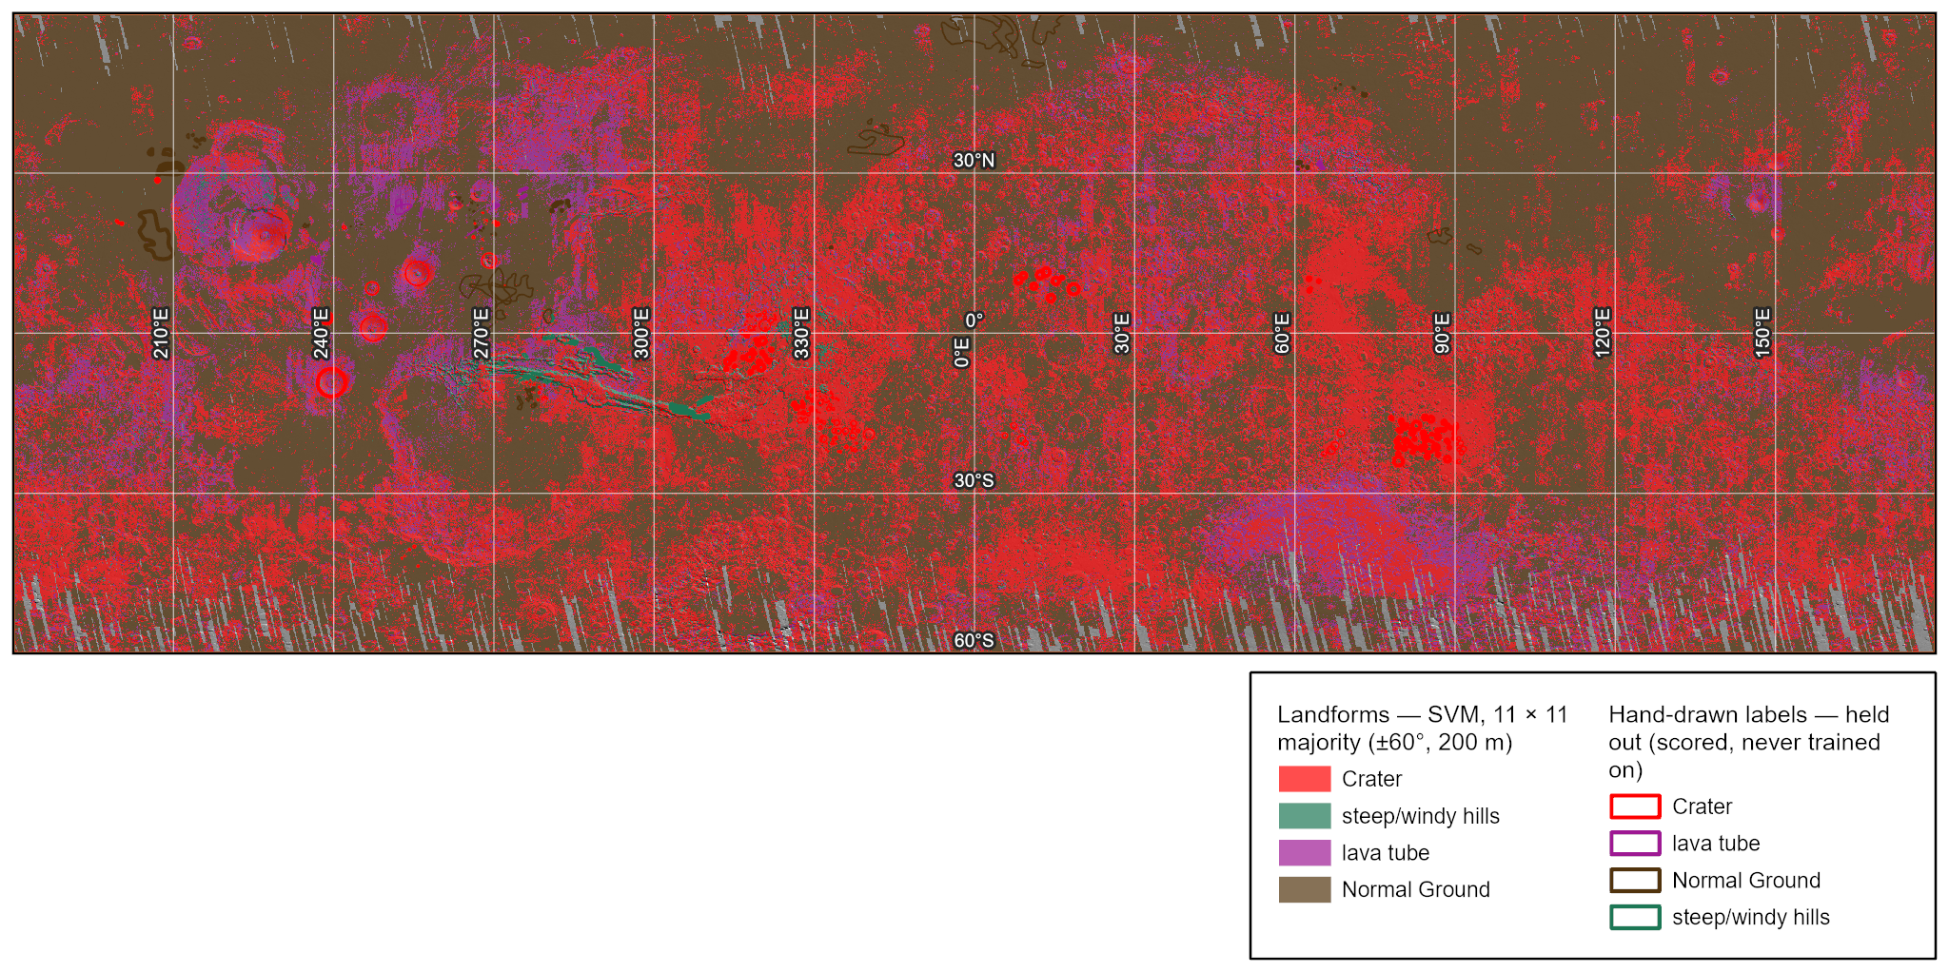
- SVM on 512 hand-drawn polygons, split by whole 15° blocks
- 200 m, smoothed 11 × 11 (2.2 km): 73.8%, κ 0.58 held out (one class everywhere: 58.6%)
- Halving the cell bought no accuracy: 69.9% raw at 200 m, 70.5% at 400 m
- Normal Ground and cratered terrain are solid; lava tube is not (2% user's)
Source: PROJECT-KNOWLEDGE.md §31.3, §55.3, §57
Figure 12. The landform classes against the USGS geologic map
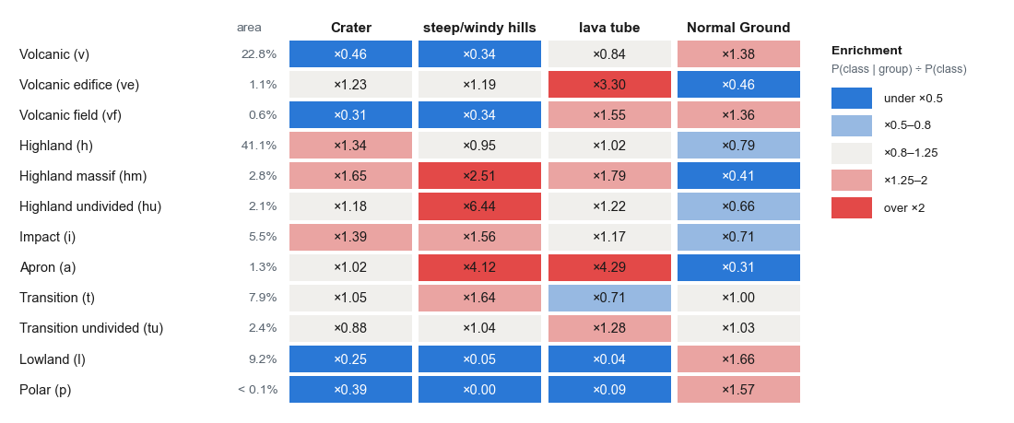
- Each cell: how much more often a class occurs in a unit group than across ±60° (×1 = no link)
- "Lava tube" is not enriched on volcanic plains (×0.84) but on volcano flanks and aprons (×3.30, ×4.29)
- 76% of the volcanic plains come out Normal Ground
- A coherent terrain map, not a lava-flow map: lava flows come from the geologic map
Source: PROJECT-KNOWLEDGE.md §43.2, §49, §57.1
Figure 13. Does thermal infrared improve the classification?
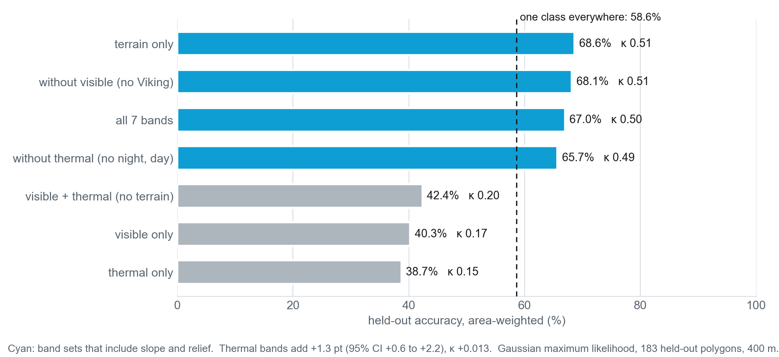
- Slope and relief alone: 68.6%, κ 0.51 held out; all seven bands: 67.0%, κ 0.50
- The thermal bands add +1.3 points (95% interval +0.6 to +2.2): real, but small
- Without terrain, visible and thermal score below one class everywhere (58.6%)
- The labelled classes are landforms, so terrain decides them; the thermal claim needs material labels
Source: PROJECT-KNOWLEDGE.md §40
Figure 14. The thermal gain, confirmed with ArcGIS Pro's own SVM
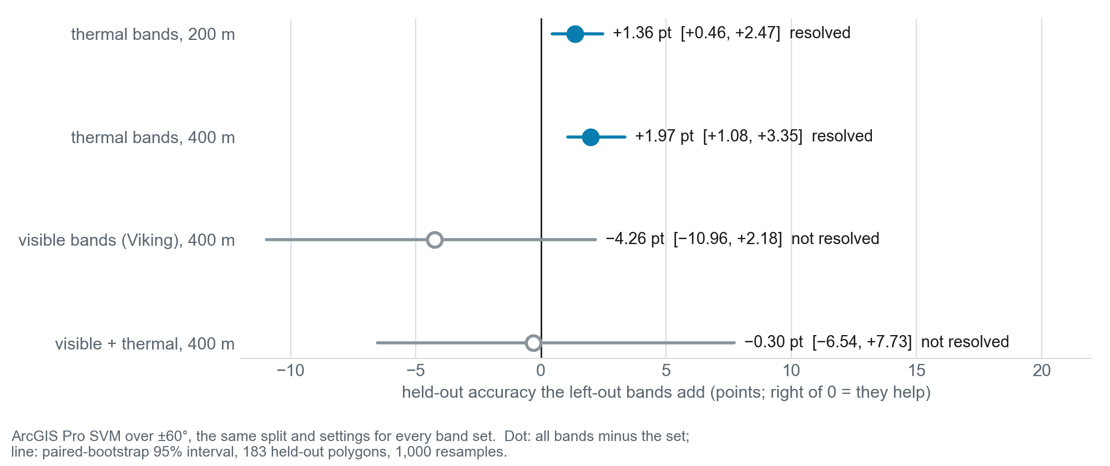
- Retrained with the published model's settings, without each band group, over the whole ±60°
- Thermal adds +1.36 points at 200 m (+0.46 to +2.47) and +1.97 at 400 m (+1.08 to +3.35)
- It helps craters and hills and hurts lava tube; dropping visible or both groups leaves the score tied
- Terrain alone ties the score but makes a poor crater map: 34 of 124 crater polygons
Source: PROJECT-KNOWLEDGE.md §56, §56.1
Figure 15. Deep learning, 1: a detector that draws boxes
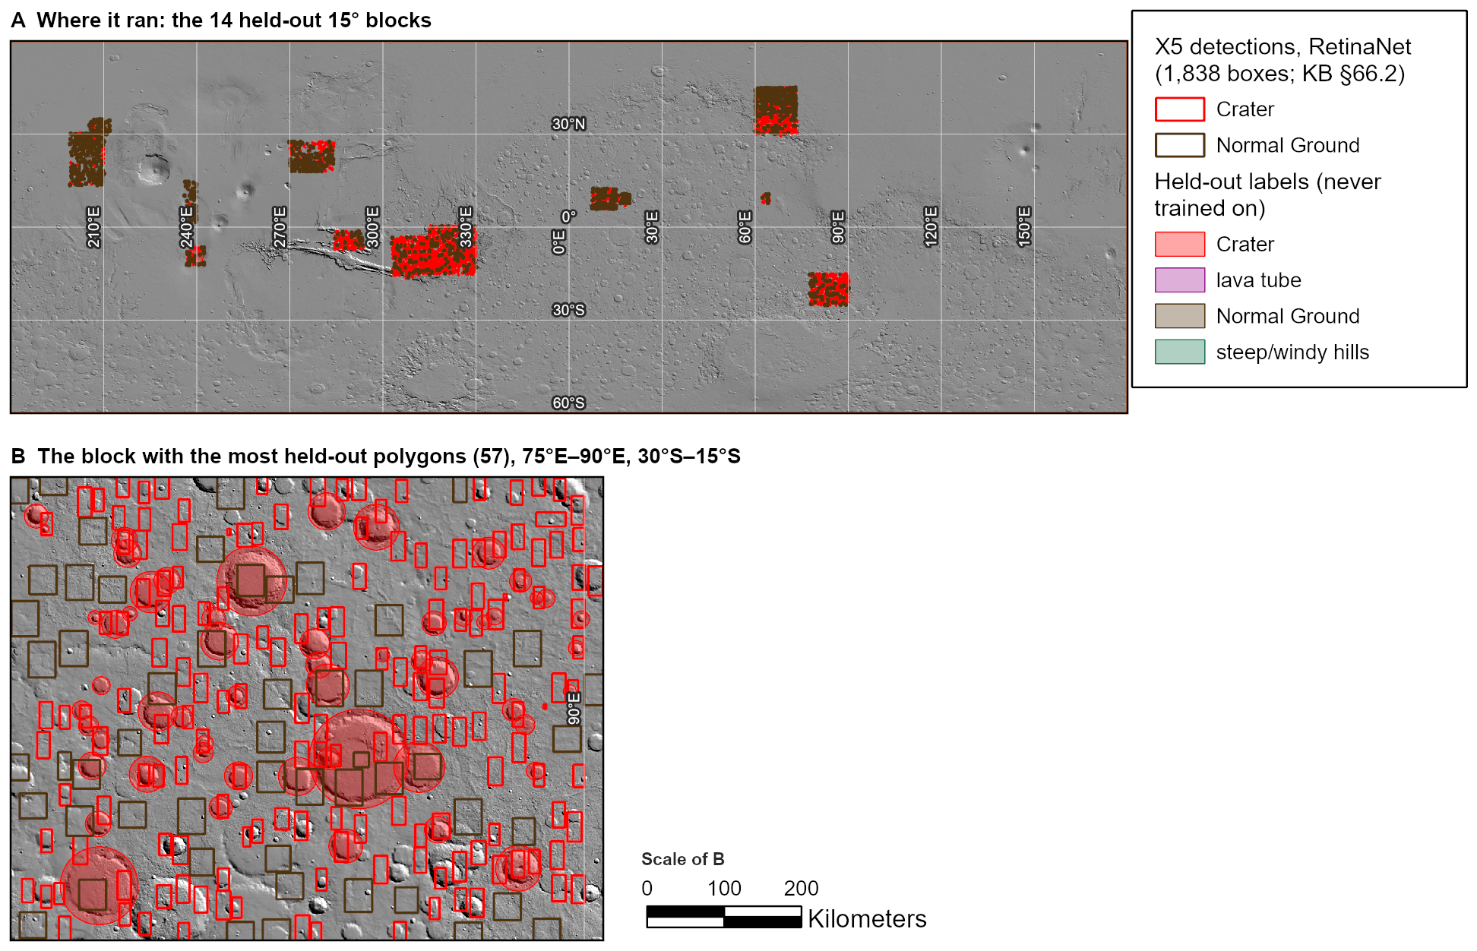
- RetinaNet on the 7-band stack, trained on the training blocks only, scored on the 183 held-out polygons
- Crater: 41.9% of polygons found, 87.6% of boxes right, against 71.1% for always naming Crater
- Normal Ground: 22.7% found, 56.9% right; hills and lava tube never named
- Retrained with the backbone unfrozen for 30 epochs: hills named, but Normal Ground found falls to 4.5%, so not improved
Source: PROJECT-KNOWLEDGE.md §66.1, §66.2, §66.5
Figure 16. Deep learning, 2: a U-Net maps terrain provinces
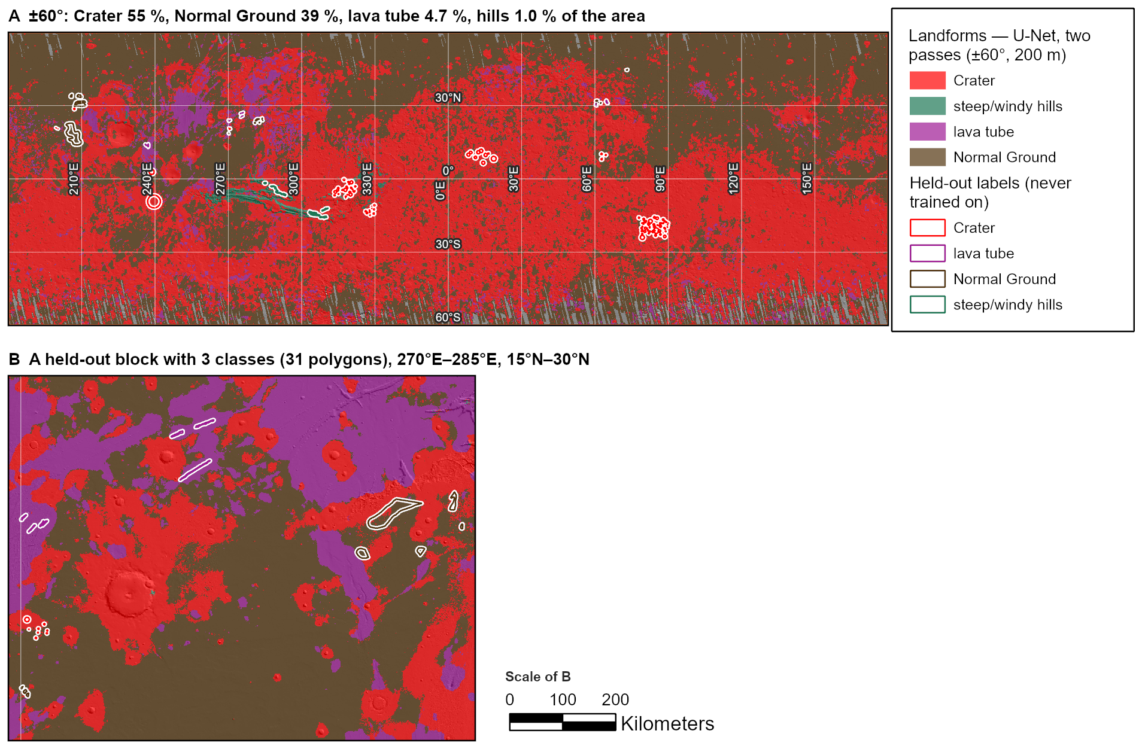
- A pixel classifier on the same stack and labels, over all of ±60°; a second pass offset 128 px removes its tile seams
- Held out: 98.9%, κ 0.980, against the published SVM map's 73.8%, κ 0.583, under the same scorer
- Lava tube becomes usable: 77.1% user's accuracy against 2.4%
- Provinces, not features: 'Crater' covers 82.6% of the ring round named craters; the SVM map stays the published one
Source: PROJECT-KNOWLEDGE.md §66.6–66.9
Figure 17. Do the infrared mosaics show lava-flow edges Viking misses? (H1)
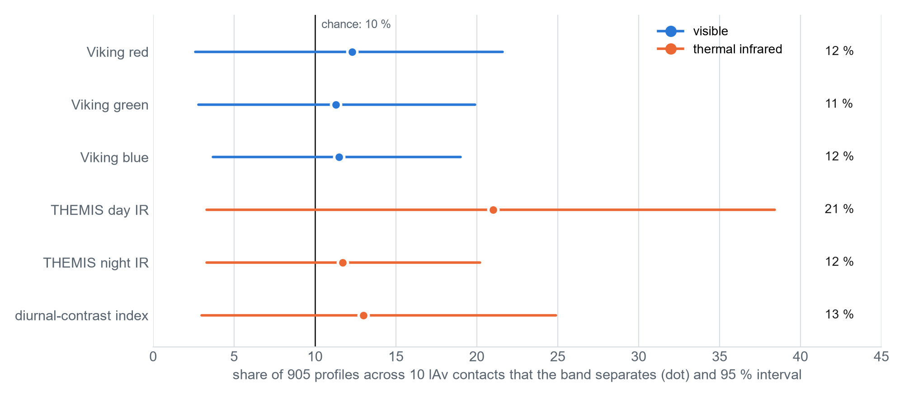
- Profiles across the geologic map's lava contacts at Athabasca: does each band tell the units apart?
- Every band does so only slightly more often than chance (10%): Viking red 12.3%, day IR 21.0%
- Day IR leans toward H1, but the intervals overlap (difference +8.7 points, −1.7 to +18.1)
- A 1:20 M map's contacts are kilometres wide: H1 is retested on margins digitised at 100 m
Source: PROJECT-KNOWLEDGE.md §47.2
Figure 18. Is the composite more stable than a single band? (H3)
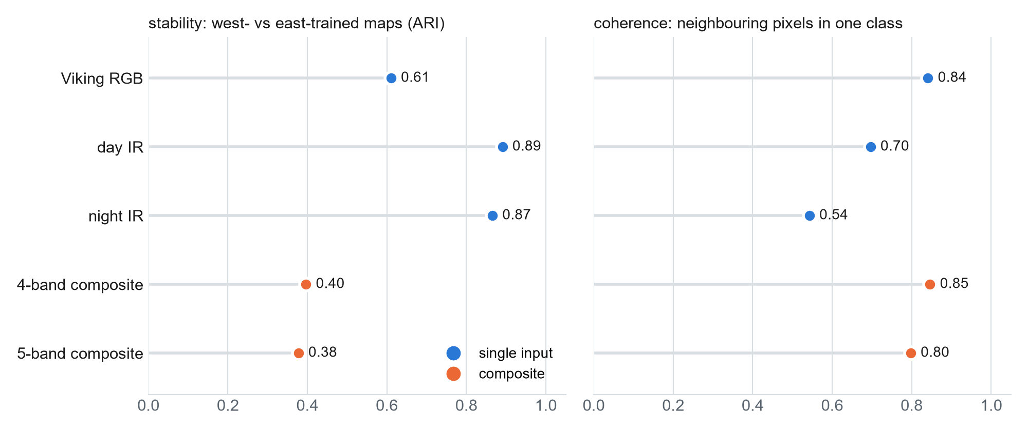
- Iso Cluster trained on the west and the east half of Ius, compared over the whole window
- The composites are the least reproducible inputs: 0.40 and 0.38, against 0.61–0.89 for single bands
- They give the smoothest maps, only just ahead of Viking (0.85 against 0.84)
- H3 is not supported
Source: PROJECT-KNOWLEDGE.md §47.3
Figure 19. How many tributary orders does 100 m resolve? (Q5)
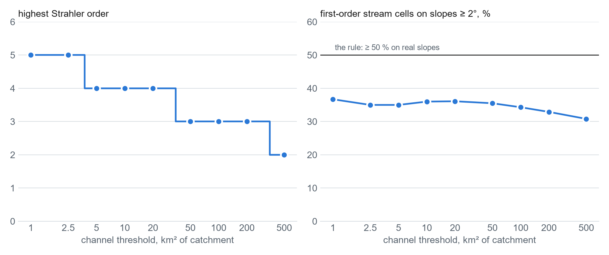
- Channel thresholds from 1 to 500 km² of catchment at Ius Chasma
- The highest stream order follows the threshold: 5 at 1 km², 3 at 50 km², 2 at 500 km²
- Only 30.8–36.7% of first-order streams lie on slopes ≥ 2°, at every threshold
- The order count is a setting, not a property of the terrain: no answer the DEM supports
Source: PROJECT-KNOWLEDGE.md §47.4
Figure 20. Do volcanic channels differ from fluvial ones? (H2)
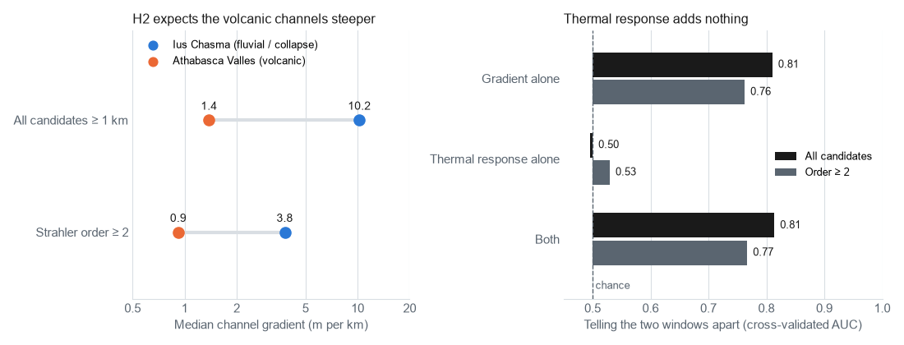
- Channel candidates, Ius Chasma (fluvial) against Athabasca Valles (volcanic): 2,588 and 3,272
- The volcanic channels are shallower, not steeper: median 1.4 against 10.2 m per km
- Thermal response tells the two apart no better than chance (AUC 0.50)
- H2 is not supported at this stage; the window, not the origin, sets the gradient; retested on reviewed channels
Source: PROJECT-KNOWLEDGE.md §51.1
Figure 21. Checking the first two classifications
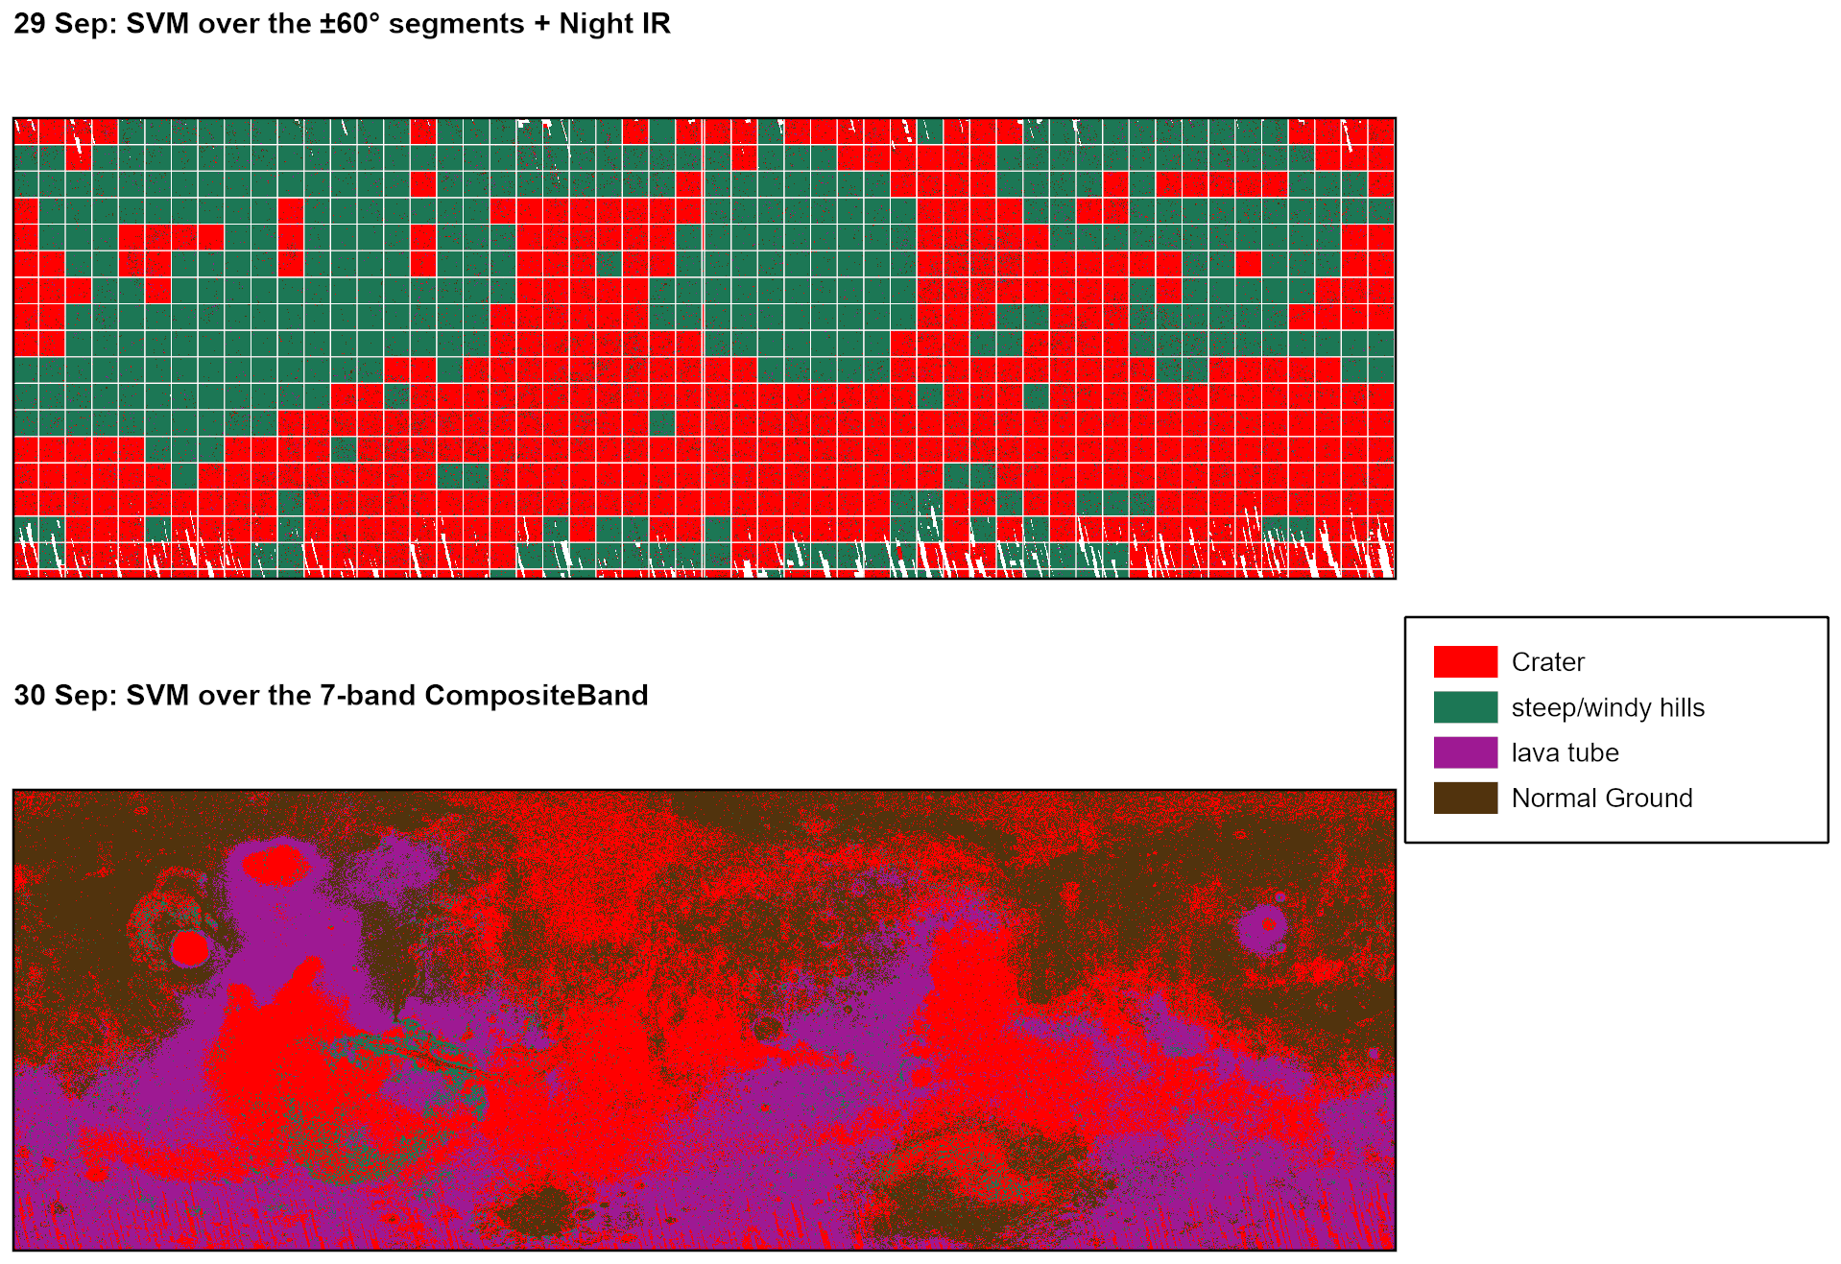
- 29 Sep map follows its 4096-px processing tiles, not the terrain
- 30 Sep map is mostly elevation: elevation alone reproduces 62% of it
- Both led to the corrected stack: no elevation band, slope in degrees
Source: PROJECT-KNOWLEDGE.md §30
7. Project Issues and Hurdles
- The thermal signal is weak where it can be checked. Against calibrated TES thermal inertia, the THEMIS mosaics keep only a weak local signal (|r| ≈ 0.1 within 15° blocks) and none across the planet; Viking albedo tracks it (r −0.31 to −0.36). In the classification the thermal bands add 1.3–2.0 points, with two classifiers (§40.1, §42.4, §43.1, §56).
- The landform classes are terrain classes. Slope and relief alone match all seven bands; against the geologic map the classes sit where terrain puts them, and "lava tube" marks volcano flanks, not lava plains (§40.1, §43.2).
- Five "Crater" labels are volcanoes. Arsia Mons alone is 31% of the held-out Crater area; seven classes are proposed (§68.2).
- Lava flows come from the geologic map. Volcanic plains are not separable from other plains in these bands; a fifth "volcanic" class tested below chance. The USGS map's volcanic units are the lava-flow reference (§43.3, §44).
- Closed depressions are not a crater count. Of the candidates ≥ 1 km, 11–13% in the type areas and 15.3% across ±60° are catalogued craters; from 5 km up most are (62.2%). Robbins (385,049 craters) is the crater reference (§42.3, §54.4).
- Four hypotheses tested, none supported. No band separates the geologic map's lava contacts much better than chance (the map is too coarse to settle H1); the composite's classes are the least reproducible input (H3); no channel threshold keeps first-order streams on real slopes (Q5); the volcanic window's channels are shallower, and thermal response separates nothing (H2, stage 1) (§47, §51).
- The review has not started. 0 of 9,287 candidates are reviewed; H1 and H2 wait for digitised features (§46).
- 250 GB on one USB drive. Reads cap near 112 MB/s, and the drive has dropped off mid-write; big outputs are built on internal disk first (§2.2, §36.4).
- Solved since September. Three coordinate frames, the z-factor defect, four failed global composites, the missing night mosaic, a defective DEM column at 180° (§15–20, §54).
8. Next Steps
- Review the 9,287 machine candidates at Ius Chasma and Athabasca Valles; draw breached craters and lava margins
- Score the candidates against the reviewed features (layout 14); retest H1 on digitised margins and H2 on reviewed channels with their origin set
- Seven classes (D17): the 1,086 proposed labels reviewed, then the SVM and U-Net rerun; both maps scored on the same held-out polygons
- Deep learning: validation blocks of its own before any further tuning, so the held-out score stays a test (§66.5)
When | What
8–26 Oct | Desktop runs done: pyramids, ±60° crater and channel pass, 200 m map, T1 in Pro, the deep-learning detector and U-Net; seven classes proposed
26 Oct | Interim data cut: what is measured by now is in the interim; the rest goes to the final
27 Oct – 22 Nov | Review and digitising; the seven-class labels and maps; H1 and H2 on digitised features; data freeze
mid-Nov | Interim presentation and report
23 Nov – 4 Dec | Final report and presentation
8 Dec | Final due

Generated 2026-10-26 by build_interim_report_live.py from interim.py, the same source as the interim presentation.

